**Name: Sanio Luke Sebastian**

**Roll No: 35**

**Batch: B**

**Date: 05-05-2022**

**NETWORKING & SYSTEM ADMINISTRATION LAB**

**Experiment No.: 6**

**Aim**

Familiarization of Shell Scripting programming.

**Procedure**

1. Write a shell scripting program to echo the details.

**Code:**

#!/bin/bash

# This is my first shell program.

echo "Hello World"

a=5

echo "a = $a"

b=4

echo "b = $b"

**Output:**

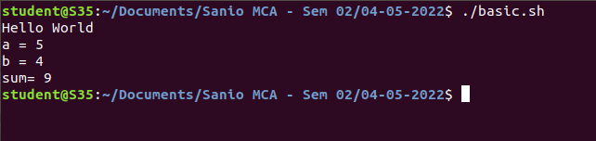

1. Write a shell scripting program to get a value from the user.

**Code:**

#!/bin/bash

echo "Enter the value of A: "

read value

echo "The entered value of A is : "$value

Output:

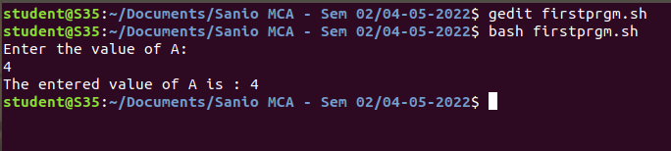

1. Write a shell scripting program to get a value from the user.

**Code:**

#!/bin/bash

#user data

echo "Enter your Name : "

read name

echo "Enter your age : "

read age

echo "Enter your educational qualification : "

read qualfn

echo "Enter your Course : "

read course

echo "Enter your College Name : "

read college

echo "Your name is : $name and your age is $age"

echo "Your lastest educational qualification is : $qualfn"

echo "Your current course is : $course and yoo are studying in $college college"

Output:

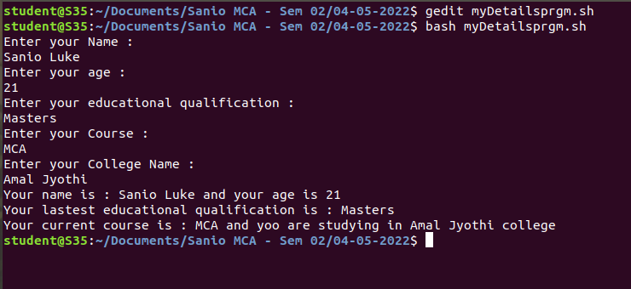

1. Write a shell scripting program to find the sum of two numbers.

**Code:**

#!/bin/bash

#sum program

echo "Enter the value for A : "

read a

echo "Enter the value for B : "

read b

sum=$(($a+$b))

echo "The sum of A=$a and B=$b is $sum"

Output:

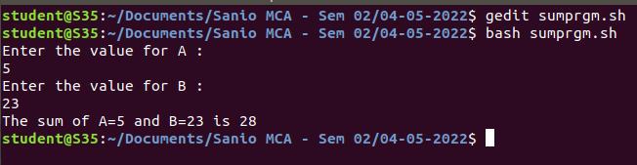

1. Write a shell scripting program to check whether the input value is even or not.

**Code:**

#!/bin/bash

#check the even or odd.

echo "Enter the number : "

read num

if [ $(($num % 2)) -eq 0 ]

then

echo "The entered number i.e. $num is a even number"

else

echo "The entered number i.e. $num is a odd number"

fi

Output:

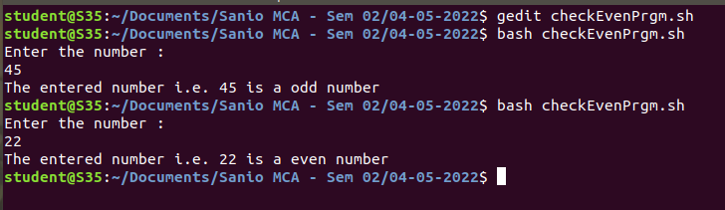

1. Write a shell scripting program to find greatest among two numbers.

**Code:**

#!/bin/bash

#Check for equals and greater than and less than.

echo "Enter 1st num : "

read num1

echo "Enter 2nd num : "

read num2

if [ $num1 -ge $num2 ]

then

echo "num1=$num1 is greater"

else

echo "num2=$num2 is greater"

fi

#if [ $num1 -eq $num2 ]

#then

#echo "num1=$num1 & num2=$num2 are equals"

#else

#echo "Both the numbers are different"

#fi

Output:

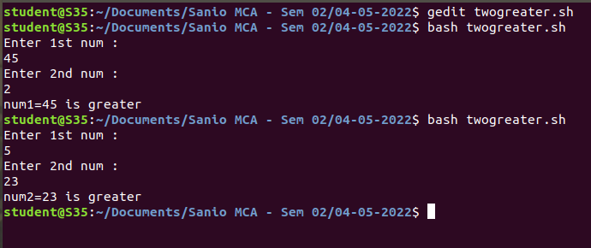

1. Write a shell scripting program to find greatest among three numbers.

**Code:**

#!/bin/bash

#check greatest among three nums

echo "Enter num1 : "

read num1;

echo "Enter num2 : "

read num2;

echo "Enter num3 : "

read num3;

if [ $num1 -gt $num2 -a $num1 -gt $num3 ]

then

echo "num1=$num1 is the largest"

elif [ $num1 -gt $num2 -a $num1 -lt $num3 ]

then

echo "num3=$num3 is the largest"

elif [ $num2 -gt $num1 -a $num2 -gt $num3 ]

then

echo "num2=$num2 is the largest"

elif [ $num2 -gt $num1 -a $num2 -lt $num3 ]

then

echo "num3=$num3 is the largest"

fi

Output:

